Section A
- What is the functional group of the esters?
Tick ( ) one box.
- COOH | 
- COO
- COH

- What small molecule is made during the formation of an ester?
Tick ( ) one box.
- Carbon dioxide
- Oxygen
- Water

- Complete the general equation for the reaction that forms an ester:

______________________ + __________________ ester + ________________

- What is the name of the ester formed through the reaction between ethanoic acid and ethanol?
Tick ( ) one box.
- Ethanol ethanoicate
- Ethane ethanolate
- Ethyl ethanoate

- Give one use of esters.

__________________________________________________________________________________________
__________________________________________________________________________________________

Section B

- The displayed formulae below show two organic compounds.
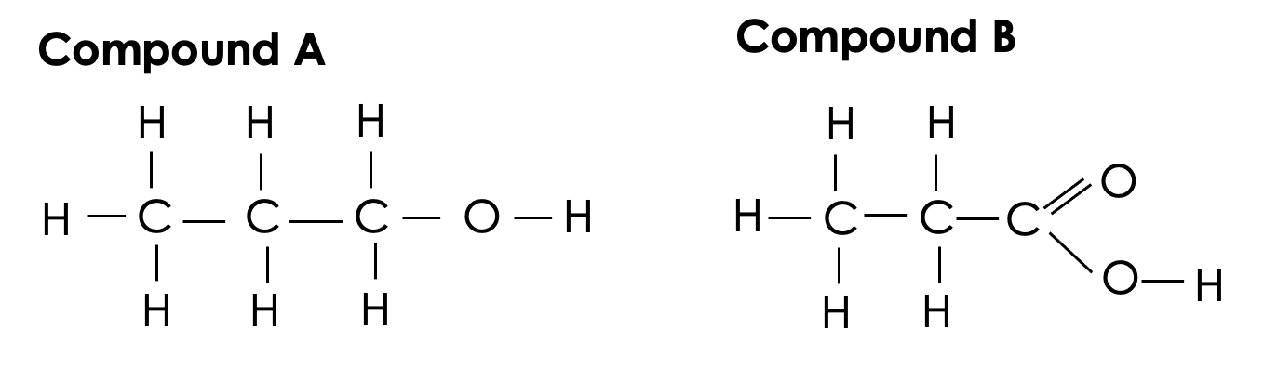

Compound A and Compound B react to form a product called propyl propanoate.

- What type of organic compound is propyl propanoate?

__________________________________________________________________________________________

- The reaction between Compound A and Compound B also forms another product. State the chemical formula of the other product.

__________________________________________________________________________________________

- Organic compounds such as propyl propanoate are useful in perfumes. Give two properties of these types of compounds that make them useful in perfumes.

__________________________________________________________________________________________
__________________________________________________________________________________________

- A student has a solution of ethanoic acid. Ethanoic acid is a weak acid.

- Explain what is meant by a weak acid.

__________________________________________________________________________________________
__________________________________________________________________________________________

- Name the edible product that contains ethanoic acid.

__________________________________________________________________________________________

- Describe how the apparatus shown below could be used to determine the concentration of the ethanoic acid solution.
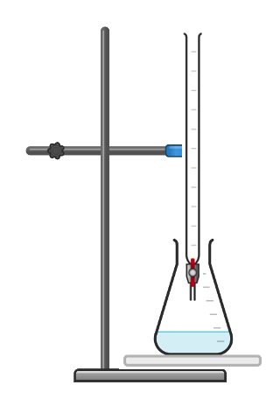
__________________________________________________________________________________________
__________________________________________________________________________________________
__________________________________________________________________________________________
__________________________________________________________________________________________
__________________________________________________________________________________________
__________________________________________________________________________________________
__________________________________________________________________________________________
__________________________________________________________________________________________
__________________________________________________________________________________________
__________________________________________________________________________________________
__________________________________________________________________________________________
__________________________________________________________________________________________
__________________________________________________________________________________________
__________________________________________________________________________________________

- Ethanoic acid can react with ethanol to form ethyl ethanoate.
Draw the displayed formula of ethyl ethanoate.

Section C

- Naturally occurring fats and oils are complex esters.
- Describe the function of fats and oils in a balanced diet.
- Describe how to use qualitative reagents to test for the presence of fats.
- Describe where the digestion of fats takes place.
- Explain why fats must be digested.
- State the products of the digestion of fats.
- Name the type of enzyme that speeds up the digestion of fats.

